Assignment-3

- Create a new custom Object called Relationship
- Create a new custom Object called Financial Account
- Create a look-up relationship between Relationship (Parent) and Financial Account(Child)
- Change the Owner ID field in Relationship and Financial Account Objects as per the above business requirements.
- We have out of the box functionality available for this feature but we want to create a similar functionality as a custom solution.

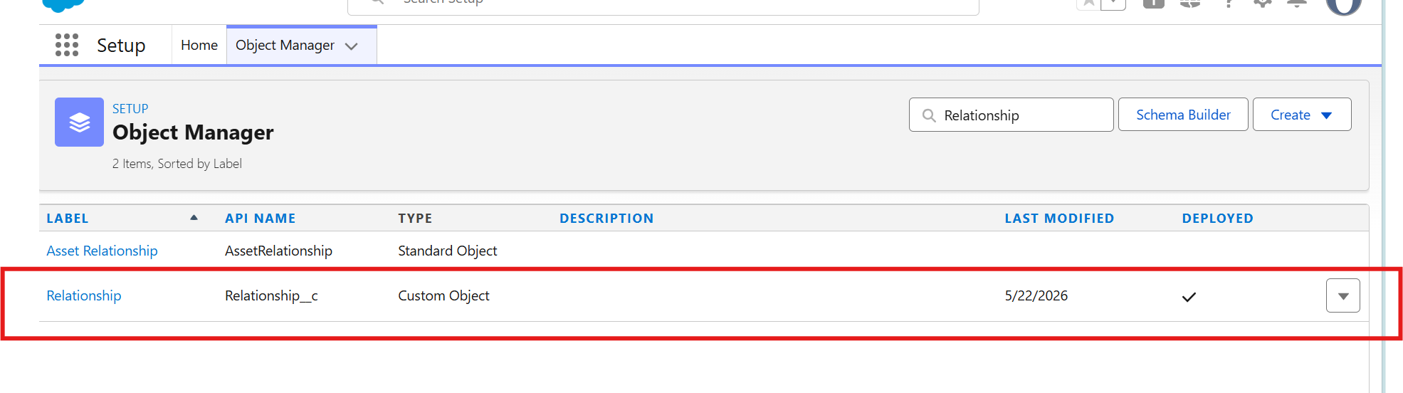

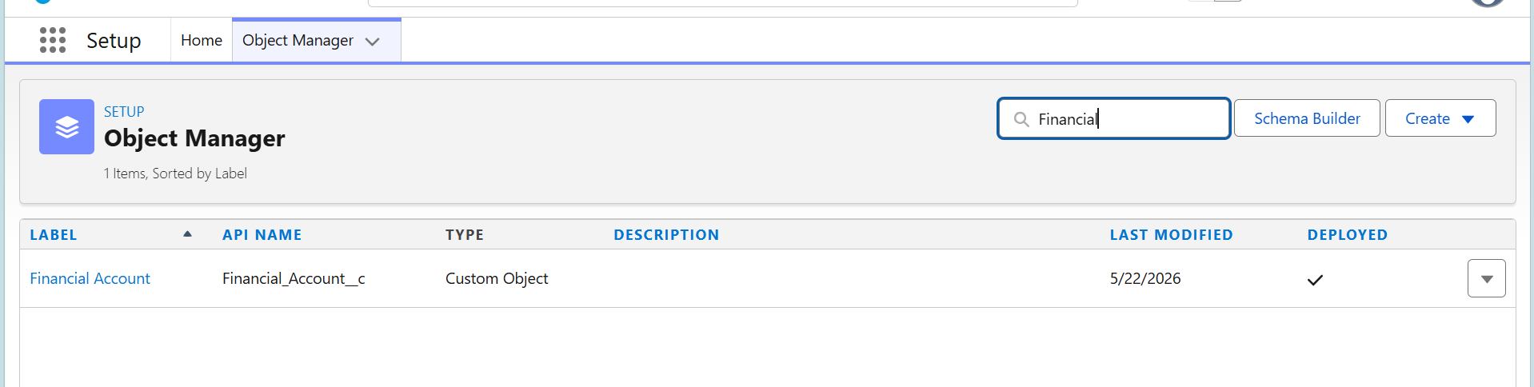
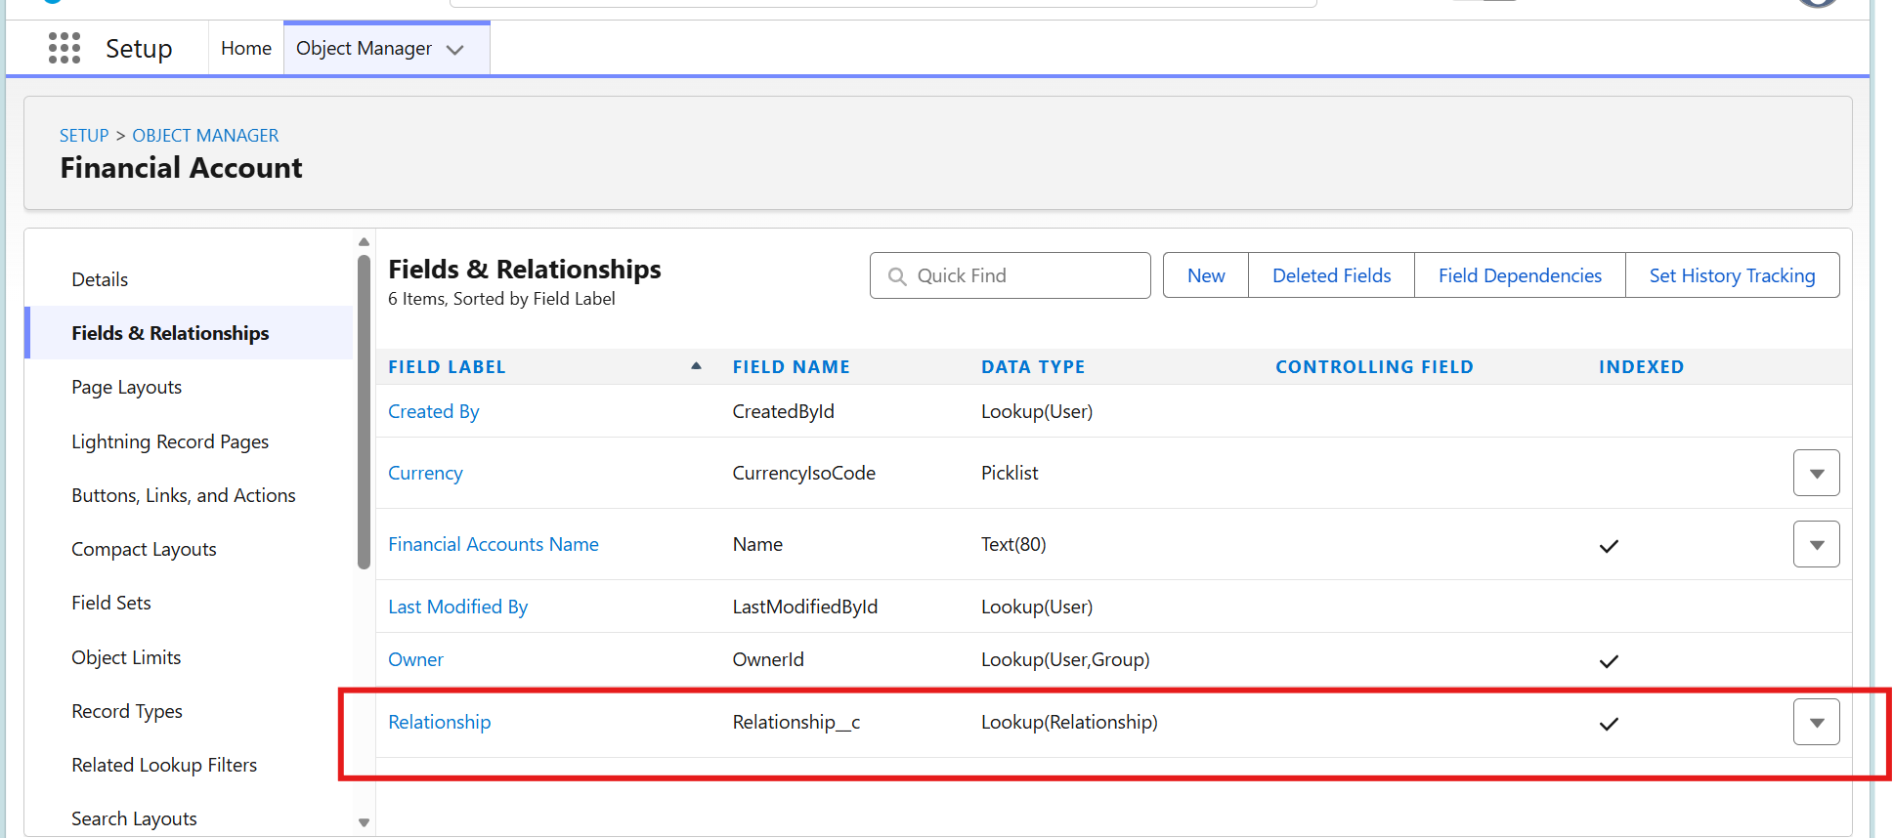

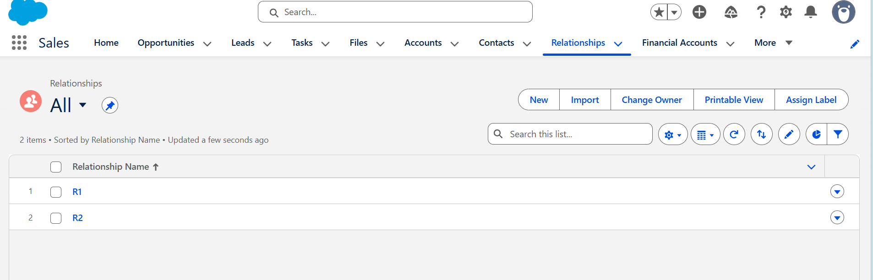

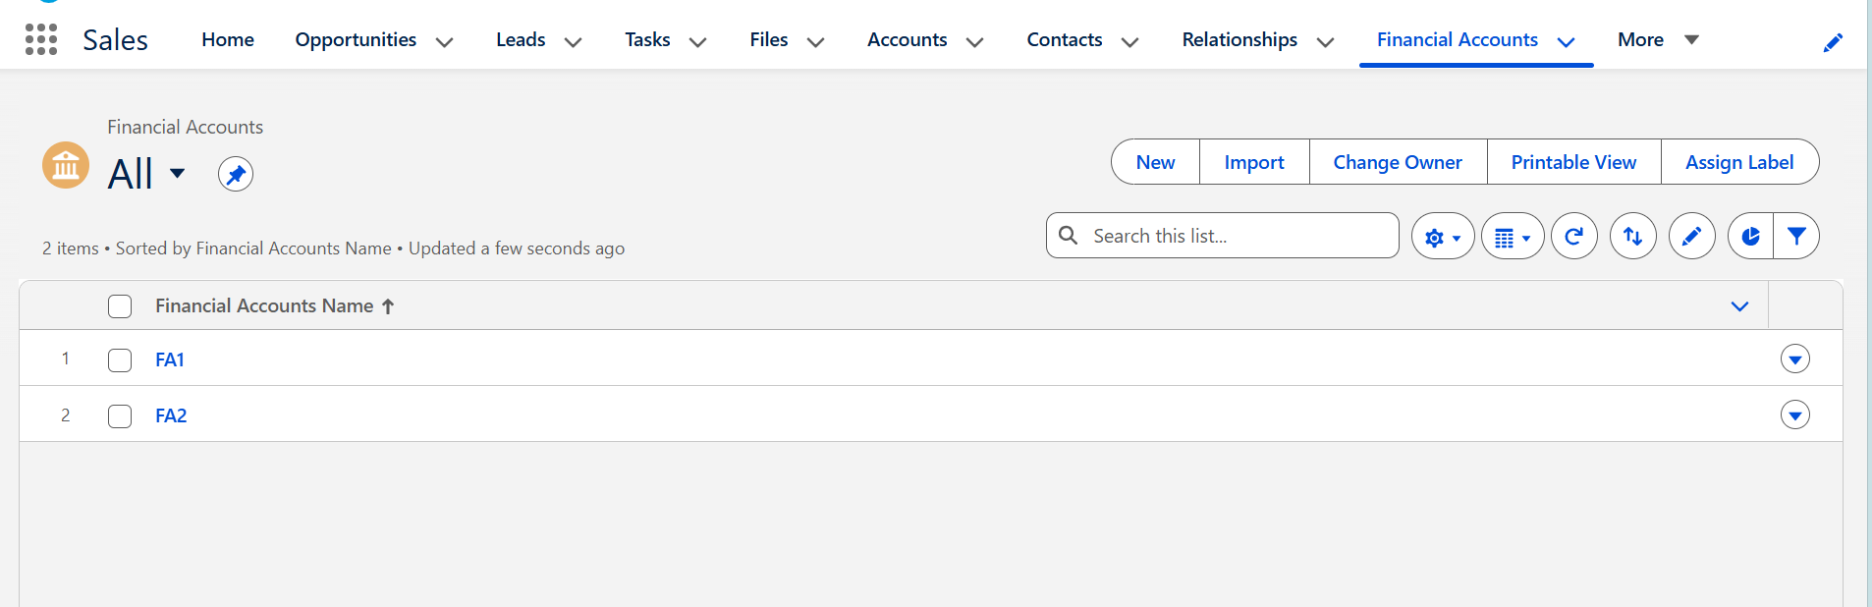

Apex Class:
public without sharing class ChangeRelationshipOwnerController {

// Store selected Relationship record IDs
public List<Id> relationshipIds {get;set;}

// Store selected new owner
public Id newOwnerId {get;set;}

// Checkbox value
public Boolean sendEmail {get;set;}

// Constructor
public ChangeRelationshipOwnerController() {

relationshipIds = new List<Id>();

// Get selected IDs from URL
String ids = ApexPages.currentPage().getParameters().get('ids');

if(ids != null && ids != '') {

List<String> idList = ids.split(',');

for(String singleId : idList) {

if(String.isNotBlank(singleId)) {
relationshipIds.add((Id)singleId.trim());
}
}
}

// Default checkbox checked
sendEmail = true;
}

// Populate active users in dropdown
public List<SelectOption> getOwnerOptions() {

List<SelectOption> options = new List<SelectOption>();

options.add(
new SelectOption('', '-- Select New Owner --')
);

for(User u : [
SELECT Id, Name
FROM User
WHERE IsActive = true
ORDER BY Name
]) {

options.add(
new SelectOption(u.Id, u.Name)
);
}

return options;
}

// Save button functionality
public PageReference save() {

// Validation
if(String.isBlank(String.valueOf(newOwnerId))) {

ApexPages.addMessage(
new ApexPages.Message(
ApexPages.Severity.ERROR,
'Please select a new owner.'
)
);

return null;
}

// Fetch Relationship records
List<Relationship__c> relList = [
SELECT Id, Name, OwnerId
FROM Relationship__c
WHERE Id IN :relationshipIds
];

// Update Relationship Owner
for(Relationship__c rel : relList) {
rel.OwnerId = newOwnerId;
}

if(!relList.isEmpty()) {
update relList;
}

// Send Email Notification
if(sendEmail) {

User newOwner = [
SELECT Id, Name, Email
FROM User
WHERE Id = :newOwnerId
LIMIT 1
];

if(newOwner.Email != null) {

Messaging.SingleEmailMessage mail =
new Messaging.SingleEmailMessage();

mail.setToAddresses(
new List<String>{newOwner.Email}
);

mail.setSubject(
'Relationship Ownership Changed'
);

String body =
'Hello ' + newOwner.Name + ',\n\n' +
'You have been assigned as the owner for the below Relationship records:\n\n';

// Add record links
for(Relationship__c rel : relList) {

String recordLink =
URL.getOrgDomainUrl().toExternalForm()
+ '/'
+ rel.Id;

body += rel.Name + ' - ' + recordLink + '\n';
}

body += '\nThank You.';

mail.setPlainTextBody(body);

Messaging.sendEmail(
new Messaging.SingleEmailMessage[] {mail}
);
}
}

// Success Message
ApexPages.addMessage(
new ApexPages.Message(
ApexPages.Severity.CONFIRM,
'Owner updated successfully.'
)
);

// Redirect to Relationship List View
PageReference pr =
new PageReference('/lightning/o/Relationship__c/list');

pr.setRedirect(true);

return pr;
}

// Cancel Button
public PageReference cancel() {

PageReference pr =
new PageReference('/lightning/o/Relationship__c/list');

pr.setRedirect(true);

return pr;
}
}

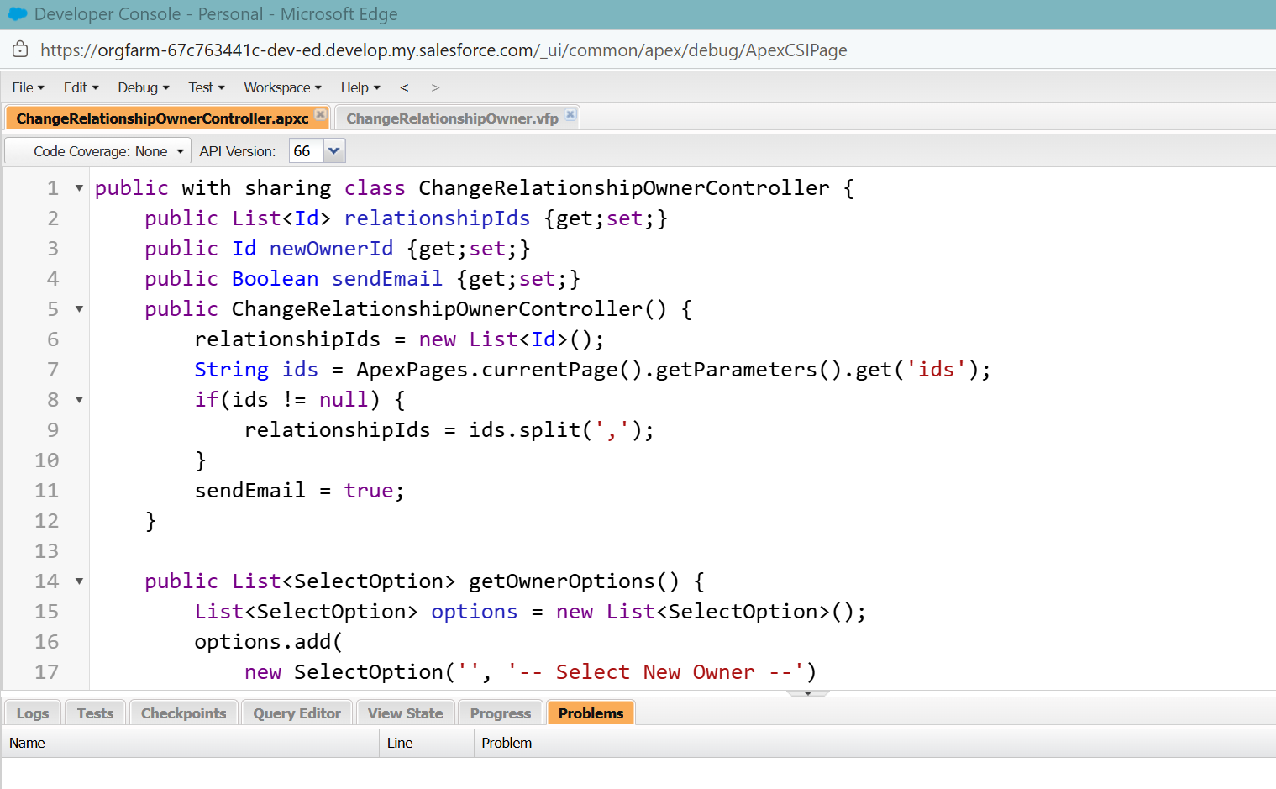

VisualForce Page:

<apex:page controller="ChangeRelationshipOwnerController">
<apex:form >
<apex:pageMessages />
<apex:pageBlock title="Mass Ownership Edit">
<apex:pageBlockSection columns="1">

<apex:selectList value="{!newOwnerId}" size="1">
<apex:selectOptions value="{!ownerOptions}" />
</apex:selectList>
<apex:pageBlockSectionItem >
<apex:inputCheckbox value="{!sendEmail}" />
<apex:outputLabel value="Send Notification Email" />
</apex:pageBlockSectionItem>
</apex:pageBlockSection>

<apex:pageBlockButtons >
<apex:commandButton value="Save"
action="{!save}" />
<apex:commandButton value="Cancel"
action="{!cancel}" />
</apex:pageBlockButtons>
</apex:pageBlock>
</apex:form>
</apex:page>

